VIET NAM GENERAL CONFEDERATION OF LABOUR

**TON DUC THANG UNIVERSITY**

**FALCUTY OF ELECTRICAL – ELECTRONIC**



**NGUYEN NGOC YEN**

**DESIGN OF AN IOT-BASED SOLAR TRACKER AND POWER MONITORING SYSTEM FOR SMART AGRICULTURE SYSTEMS**

**UNDERGRADUATE THESIS OF ELECTRICAL ENGINEERING**

**HO CHI MINH CITY, YEAR 2023**

VIET NAM GENERAL CONFEDERATION OF LABOUR

**TON DUC THANG UNIVERSITY**

**FALCUTY OF ELECTRICAL – ELECTRONIC**



**NGUYEN NGOC YEN – 418H0392**

**DESIGN OF AN IOT-BASED SOLAR TRACKER AND POWER MONITORING SYSTEM FOR SMART AGRICULTURE SYSTEMS**

**UNDERGRADUATE THESIS OF ELECTRICAL ENGINEERING**

Advised by

**Dr. Fayaz Hussain**

**HO CHI MINH CITY, YEAR 2023**

**ACKNOWLEDGEMENTS**

I want to express my profound gratitude to all the instructors at Ton Duc Thang University, especially those in the Department of Electrical and Electronics Engineering, for their enthusiastic instruction and transfer of invaluable knowledge.

My sincere gratitude goes out to Mr. Fayaz Hussain, who oversaw the project directly, for his committed assistance, inspiration, and setting up the necessary framework that allowed me to finish the job effectively. In addition, I could not have finished my research without Dr. Dinh Hoang Bach's assistance; your advice and criticism enabled me to improve the project's completion.

In conclusion, I would like to express my gratitude to my family and friends, who have never left my side and have always created an environment of care, support, and encouragement as I studied and finished my graduation project.

*Ho Chi Minh City,*

*Author*

This thesis was carried out at Ton Duc Thang University.

Advisor: Dr Fayaz Hussain.........................................................

......................................................................................

*(Title, full name and signature)*

This thesis is defended at the Undergraduate Thesis Examination Committee was hold at Ton Duc Thang University on 16 /07/2023

Confirmation of the Chairman of the Undergraduate Thesis Examination Committee and the Dean of the faculty after receiving the modified thesis (if any).

**CHAIRMAN DEAN OF FACULTY**

…………………………. ………………………………

**DECLARATION OF AUTHORSHIP**

I hereby declare that this thesis was carried out by myself under the guidance and supervision of Dr. Fayaz Hussain; and that the work contained and the results in it are true by author have not violated research ethics. The data and figures presented in this thesis are for analysis, comments, and evaluations from various resources by my own work and have been duly acknowledged in the reference part.

In addition, other comments, reviews, and data used by other authors, and organizations have been acknowledged and explicitly cited.

**I will take full responsibility for any fraud detected in my thesis.** Ton Duc Thang University is unrelated to any copyright infringement caused on my work (if any).

*Ho Chi Minh City, 21st January 2023.*

*Author*

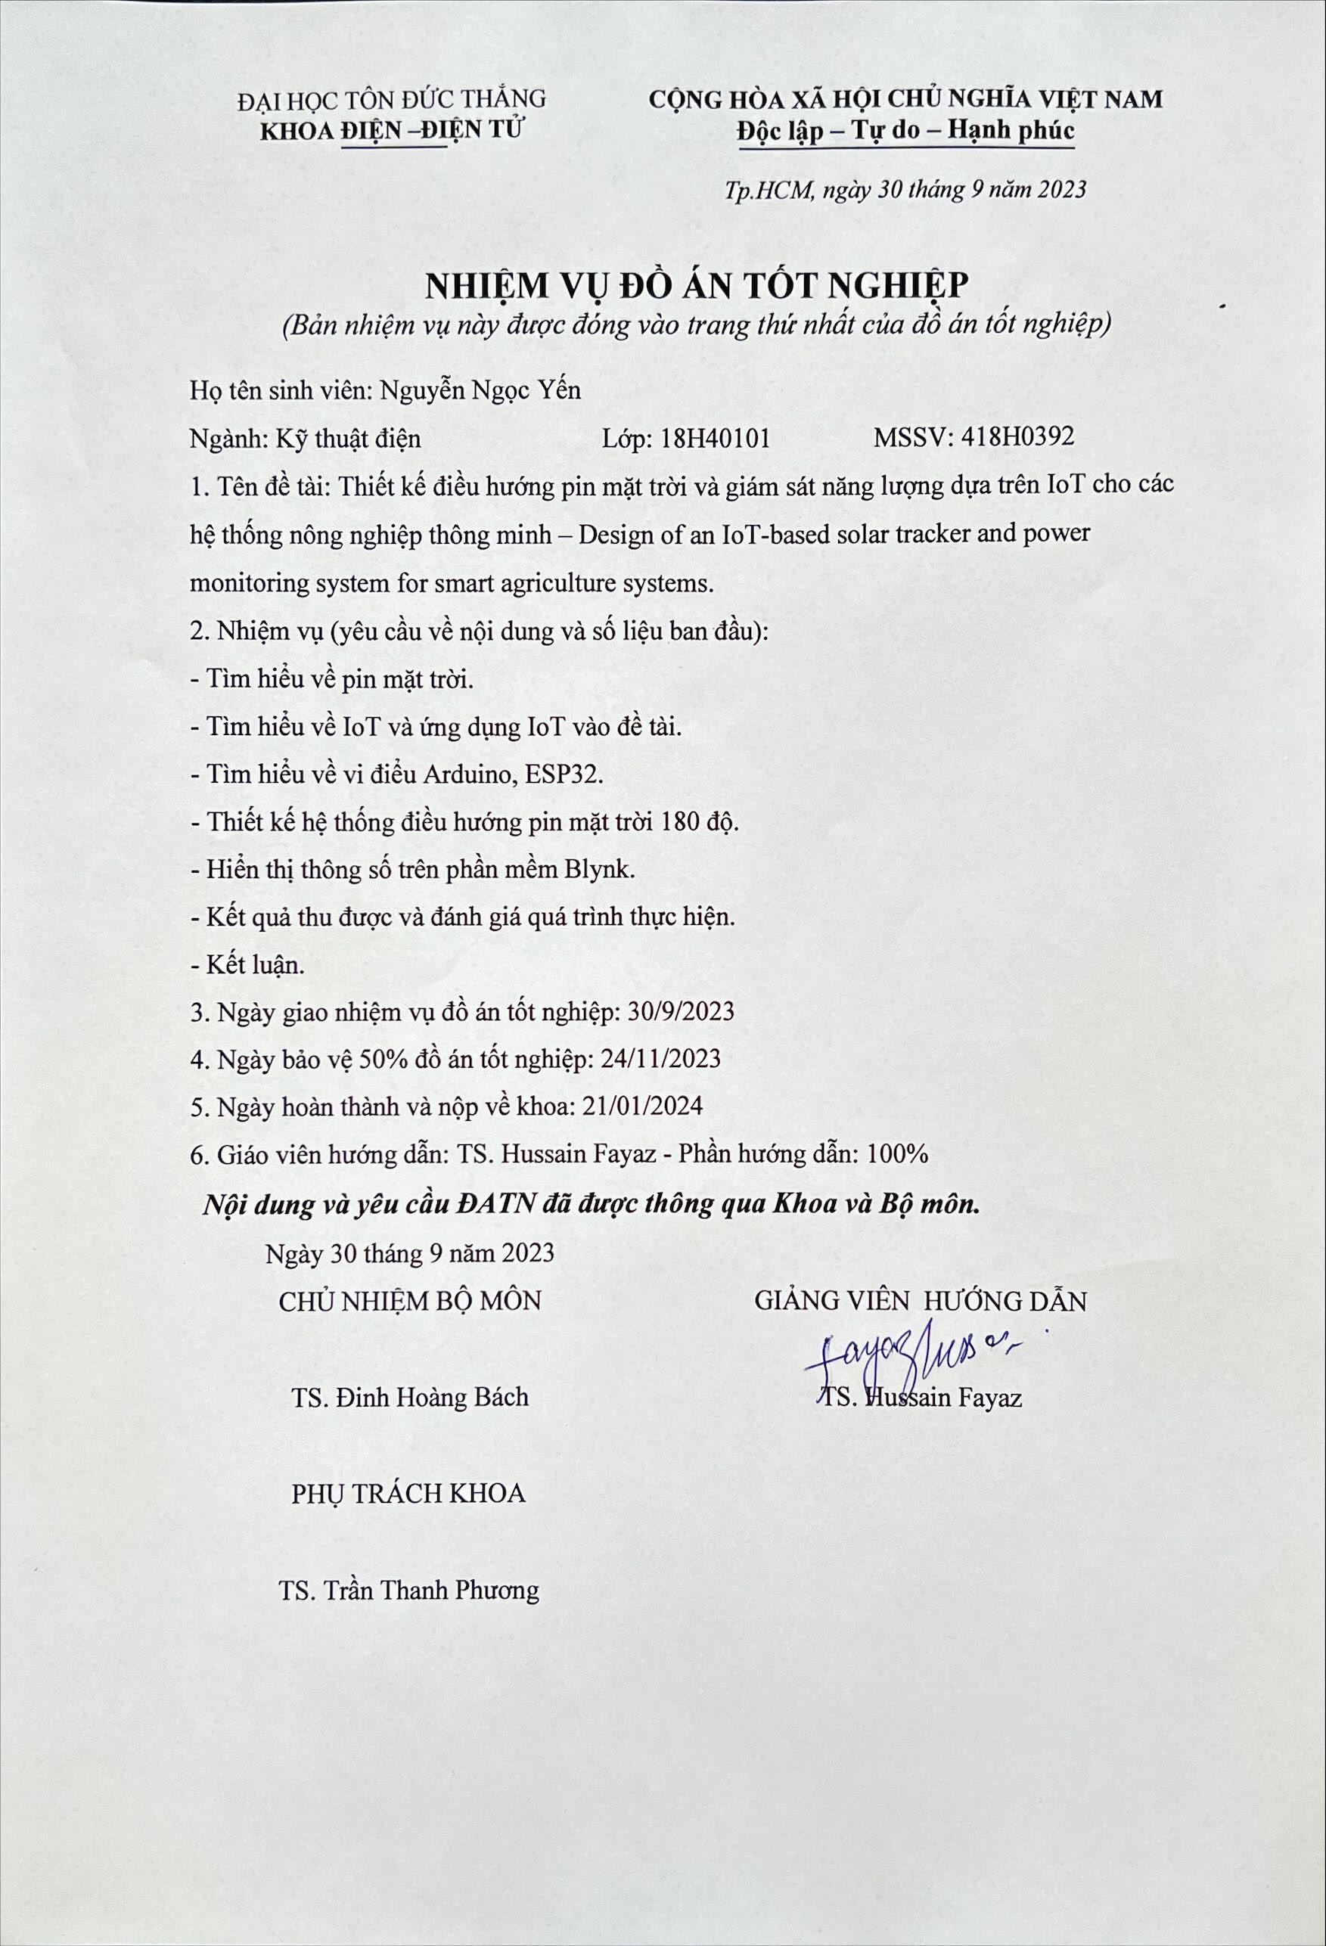

|  |  |
| --- | --- |
| TON DUC THANG UNIVERSITY  **FACULTY OF ELECTRICAL AND ELECTRONIC ENGINEERING**  ------------------- | SOCIALIST REPUBLIC OF VIETNAM  Independence – Freedom – Happiness  ---------------------- |

**GROUP PROJECT SCHEDULE**

Student: Nguyễn Ngọc Yến

Class: 18H40101 Student ID: 418H0392…………

Project: Design of an IoT-based solar tracker and power monitoring system for smart agriculture systems.

|  |  |  |  |
| --- | --- | --- | --- |
| **Week/Day** | **Work** | | **Advisor signed** |
| **Done** | **Continue** |
| Week 1 (25/09/2023 - 01/10/2023) | Meet with the advisor to know the requirements of the project, proceed to select the topic of the project. | The advisor show the overview of the topic. |  |
| Week 2 (02/10/2023 - 08/10/2023) | Found the topic for the project. The advisor recommended project’s system. | Study about Solar Basis, solar panels, tracking solar and IOT. |  |
| Week 3  (09/10/2023– 15/10/2023) | Looking for hardware, learn how it works. | Collect enough components, understand the nature of components. |  |
| Week 4  (16/10/2023 - 22/10/2023) | Learn Arduino programming language to apply for every sensors in the system. | Understanding the sensor pins out diagram |  |
| Week 5  (23/10/2023 - 29/10/2023) | Learn ESP8266 programming language to apply for every sensors in the system. | Connected components with Arduino and ESP8266 . microcontroller. |  |
| Week 6  (30/10/2023 - 05/11/2023) | Learned about basics of code for run equipments | Understanding the sensor pins out diagram. |  |
| Mid-term check | Evaluation of completed volume ……%  be allowed to continue/discontinue | | |
| Week 7  (06/11/2023 – 12/11/2023) | Try to connect pins of sensor to Arduino | Started code in arduino |  |
| Week 8  (13/11/2023 – 19/11/2023) | Research on photoresistance, how to design tracking solar system | Get an overview of how it works |  |
| Week 9  (20/11/2023 – 26/11/2023) | Buy the necessary components: photoresistor, servoMG996, iron frame, .. | Completed tracking solar system. |  |
| Week 10  (27/11/2023 – 03/12/2023) | Do send data to blynk | Finishing model and test again all project |  |
| 50% progress assessment | | | |
| Week 12  (11/12/2023 – 17/12/2023) | Meet french students, talk about machine learning | Collect data from air conditioning, apply code and analysis |  |
| Week 13  (18/12/2023 – 24/12/2023) | Write the graduation thesis | Completed graduation thesis |  |
| Week 14  (25/12/2023 – 31/12/2023) | Make a powerpoint to present | Completed the powerpoint |  |
| Week 15  (01/01/2024 – 07/01/2024) | Completed 100% Graduation Project |  |  |
| Submit | Complete …..% Undergraduate thesis  be protected/unprotected Undergraduate thesis. | | |

**DESIGN OF AN IOT-BASED SOLAR TRACKER AND POWER MONITORING SYSTEM FOR SMART AGRICULTURE SYSTEMS**

**ABSTRACT**

Solar energy has been a topic of great interest and research worldwide, and it is being increasingly utilized. However, current solar energy systems are often fixed, which reduces the efficiency of energy harvesting from solar panels. Solar panels achieve their maximum efficiency when the sunlight is perpendicular to their surface. Therefore, I have decided to research the topic of "Design of an IoT-based solar tracker and power monitoring system for smart agriculture systems". By using a servo motor and light sensors, the system can track and adjust the position of the solar panel to ensure that it receives sunlight at the correct angle. This improves energy harvesting efficiency and enhances the utilization of solar energy throughout the day. Additionally, the use of IoT technology and devices such as Arduino, ESP32, Lora SX1278, and the Blynk application allows for remote monitoring of the system. Users can monitor energy performance, the position of the solar panel, and collect data from the solar energy system.

**CONTENTS**

LIST OF FIGURES 3

LIST OF TABLES 5

CHAPTER 1. INTRODUCTION 7

1.1 Introduction 7

1.2 The objectives of the topic 8

CHAPTER 2. LITERATURE REVIEW 9

2.1 Overview about solar energy 9

2.1.1 Definition 9

2.1.2 Global solar energy 10

2.1.3 Solar energy in Vietnam 12

2.2 Solar panel 13

2.2.1 Structure 14

2.2.2 Working principle 16

2.2.3 ‘m 16

2.2.4 Application 17

2.3 Overview of the Internet of Things 20

CHAPTER 3. METHODOLOGY 21

3.1 System overview 21

3.2 Components 22

3.2.1 Solar panel 22

3.2.2 Solar charge control 23

3.2.3 Battery 24

3.2.4 Photodiode sensor 25

3.2.5 Servo motor 26

3.2.6 Lora 28

3.2.7 Arduino 29

3.2.8 Module Wi-Fi ESP32 30

3.3 Design of an electronic circuit. 31

3.3.1 Control circuit 31

3.4 The Blynk platform 31

CHAPTER 4. RESULTS AND DISCUSSION 33

4.1 Describe the operating procedure 33

4.2 Solar tracking operation 34

4.3 Analysis 35

4.3.1 Testing without tracking solar 35

4.3.2 Testing with tracking solar 36

4.3.3 Comparison 37

CHAPTER 5. CONCLUSIONS 41

5.1 Final Hardware 41

5.2 Advantage of model 43

5.3 Disadvantage of model 43

5.4 Future Works 43

REFERENCES 45

# LIST OF FIGURES

Figure 2‑1: Radiation from sun to earth 9

Figure 2‑2: Renewable energy capacity growth 10

Figure 2‑3: Top 10 nations with the most solar capacity in 2021 11

Figure 2‑4: Vietnam's map of solar radiation 13

Figure 2‑5: Solar panel structure 14

Figure 2‑6: The working principle of solar cell 16

Figure 2‑7: Solar-powered backpack 17

Figure 2‑8: Street lights powered by solar 17

Figure 2‑9: An Hao solar power plant 18

Figure 2‑10: The house is equipped with solar batteries 19

Figure 2‑11: Internet of Things 20

Figure 3‑1: Solar panel 22

Table 3‑1: Solar panel technical speFigure 3‑2cifications 22

Figure 3‑3: Solar power manager 5V 23

Figure 3‑4: 24

Figure 3‑5: 24

Figure 3‑6: Battery 18650 26

Figure 3‑7: Photodiode light sensor 27

Figure 3‑8: RC Servo 9G motor 28

Figure 3‑9: Lora SX1278 433Mhz 3000m 29

Figure 3‑10: Arduino Uno R3 30

Figure 3‑11: ESP32 31

Figure 3‑12: Blynk interface 33

Figure 4‑1: Operation diagram 34

Figure 4‑2: Testing without non-tracking solar 37

Figure 4‑3: Voltage difference between 2 cases 39

Figure 4‑4: Current difference between 2 cases 39

Figure 4‑5: power obtained in 10 hours between 2 cases 40

Figure 5‑1: The solar tracking of PV systems with hospital smart systems 42

Figure 5‑2: Outcome on Blynk App 43

# LIST OF TABLES

Table 3‑1: Solar panel technical speFigure 3‑2cifications 21

Table 3‑2: The solar power manager 5V technical specifications 24

Table 3‑3: Technical specifications of the 18650 batteries 25

Table 3‑4: Technical specifications of photodiode light sensors 26

Table 3‑5: Technical specifications of the RC servo 9G motor 27

Table 3‑6: Technical specifications of the Lora SX1278 433Mhz 3000m 28

Table 3‑7: Technical specifications of the Arduino Uno R3 29

Table 3‑8: Technical specifications of the ESP32 31

Table 4‑1: Measured parameters without the tracking solar system 36

Table 4‑2: Measured parameters with the tracking solar system 37

# INTRODUCTION

## Introduction

Country development and population growth are leading to an increase in demand for energy. However, while energy demand is increasing, exploited fossil energy sources are increasingly depleted and becoming scarce. Emissions from the burning of fossil fuels, including coal, oil, and natural gas, have contaminated the air. Emissions such as CO2, NO2, and SO2 are released into the atmosphere, causing the greenhouse effect, climate change, and harmful effects on human health.

In the agricultural sector, the development of smart agricultural systems and related technologies is also increasing energy demand. To meet this need, though, will require the use of fossil fuels, which will exacerbate environmental issues and raise emissions in the agriculture sector.

Therefore, there is a general trend toward finding clean and sustainable energy sources to meet this need. Solar energy is one of the renewable energy sources available today that is seen to have potential and work well with intelligent agriculture systems. It is a never-ending renewable energy source that slows down climate change, stops pollution in the environment, and lowers carbon emissions.

On the other hand, Vietnam is a nation with enormous solar energy potential. It has consistent and ample sunlight throughout the year due to its proximity to the equator. The development and application of solar energy in numerous fields is facilitated by this situation.

Solar panels can only operate at their best efficiency when the sun's rays are directed perpendicular to their plane. Unfortunately, a lot of modern solar panel systems are installed permanently, which lowers the panels' efficiency in harvesting energy. To maintain the performance of the panels at the highest level. We need a system to adjust the panels so that they face the sun so that the photovoltaic cells (solar cells) receive a more optimal amount of light, which will help increase solar energy collection efficiency.

Based on the practical needs, I use Internet of Things (IoT) technology to "design an IoT-based solar tracker and power monitoring system for smart agriculture systems." Through the use of a sensor system that gathers data on the smartphone app over the Internet, users may monitor and navigate the system remotely and consistently reach peak performance. Makes a significant contribution to the development of a high-performance solar energy system, a safe system, high economic efficiency, and improved professionalism

## The objectives of the topic

The application of IoT to the solar panel system will help users to monitor the operation of the device remotely in real time and help reduce operating costs. This management measure will allow for the most efficient use of solar energy. Simultaneously, the Internet of Things application system for system navigation and monitoring helps to create a safe system with great economic efficiency. The system has a photodiode light sensor to measure light intensity. The information collected from the sensor will be sent to the Arduino microcontroller for processing and sent to the user via the Internet using the ESP32 module. Users will use the app Blynk to track and monitor the system's operating status. From there, adjust the direction of the system so that the solar cell surface always faces the sun to collect the most energy. The parameters will be sent to the smartphone via the Internet.

# LITERATURE REVIEW

## Overview about solar energy

### Definition

Solar energy is the energy derived from the sun's radiant energy and heat. This is a precious, endless source of energy from nature, available all over the world, and easy to exploit and use. Additionally, solar energy is a clean and renewable source of energy that does not produce harmful pollutants, making it an environmentally friendly alternative to traditional sources of energy.

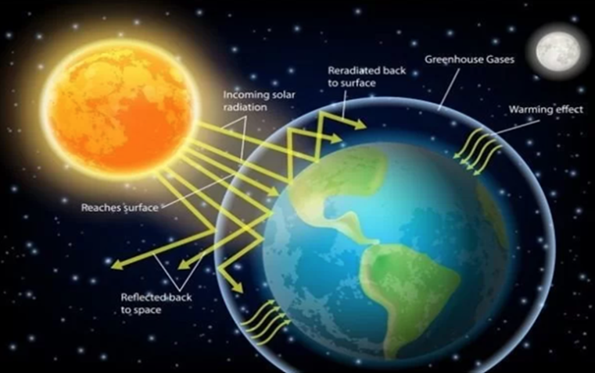

Figure ‑: Radiation from sun to earth

On clear days with few clouds, the amount of solar radiation energy that reaches the earth's surface is at its highest, measuring roughly 1,000W/m2. It can be said that heat radiation from sunlight shining on the earth is infinite, this is an energy source that can be regenerated daily, monthly, yearly... NASA research indicates that humans will be able to benefit from sunlight and this star for around 6.5 billion years. As a result, humans can use this energy source without restriction or concern about its depletion.

There are two primary ways to utilize solar energy:

* Solar thermal energy uses sunlight to create heat and convert it into thermal energy. Thermal solar systems can be used for various applications, such as space heating and cooling, water heating, and industrial process heat.
* Solar electricity is the direct conversion of solar energy in the form of light into electricity. Solar power systems can replace grid power to serve daily activities and production. It is one of the fastest-growing renewable energy technologies and is playing an increasingly important role in the global energy transition.

Both of these methods harness the abundant energy from the sun and can be employed in various applications.

### Global solar energy

Solar energy is a growing industry around the world, with many countries investing in solar technologies to meet their energy needs cleanly and sustainably. In addition, solar energy is being used more and more globally, and it is becoming a significant energy source. The advancement of solar energy will lessen reliance on conventional energy sources and lessen adverse environmental effects.

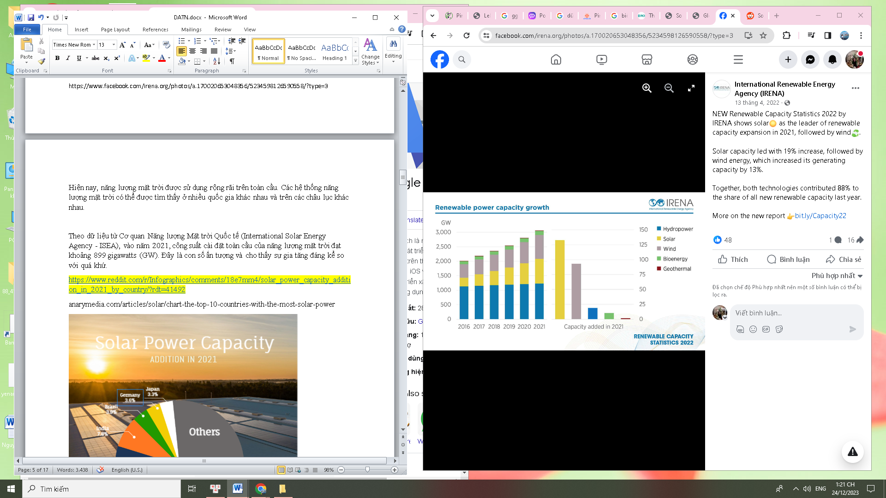

Figure ‑: Renewable energy capacity growth

Solar energy was the leading source in expanding renewable capacity in 2021, according to data released by the International Renewable Energy Agency (IRENA) for 2022. This suggests that solar energy is becoming increasingly popular and widely used, playing a major role in the global shift to renewable energy sources.

A record 179 TWh (a 22% increase) in global solar PV output was produced in 2021, according to an IRENA report. In 2021, the total solar capacity worldwide was 849 GW.

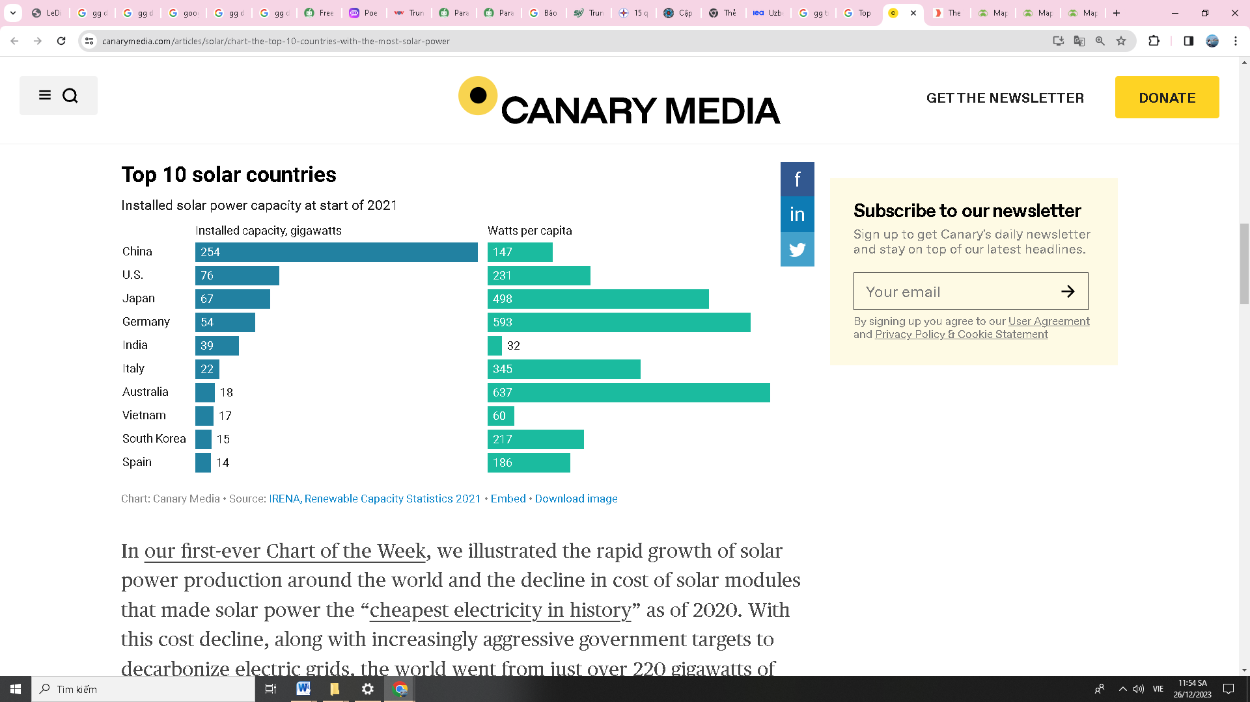

Figure ‑: Top 10 nations with the most solar capacity in 2021

China, the US, Japan, Germany, India, Italy, Australia, Vietnam, South Korea, and Spain are the top ten countries in the world in terms of installed solar PV capacity as of 2021. These countries collectively account for more than two-thirds of the world's solar PV capacity.

The world leader in installed solar capacity is China at 254 gigawatts , accounting for 35.6% of the global total. The US came in second with 76 GW, or 10.6% of the total. With 17 GW of installed solar power, Vietnam presently holds the eighth-place position among the top ten countries in the world, accounting for 2.3% of the total. Vietnam currently ranks 8th in the top 10 places with the largest installed solar power capacity in the world with 16,504MW, accounting for 2.3% globally.

China is the biggest manufacturer of solar panels worldwide and has made significant investments in solar energy in recent years.

In general, it is anticipated that the worldwide solar energy market will keep expanding in the years to come as costs continue to drop and technology advances, making solar energy a more attractive option to conventional energy sources.

### Solar energy in Vietnam

Vietnam has a lot of potential for the development of solar energy systems because of its ideal climate, which includes plenty of sunshine all around the nation. In recent years, Vietnam has become one of the fastest-growing solar markets in the world, with installed solar capacity exceeding 17 GW by 2021.

The special thing is that our country is favored by God for its potential to exploit solar power when there is quite a large amount of solar radiation. On average, Vietnam has good sunshine hours, especially in the provinces in the southern region, so the exploitation of solar power is also high. Like wind energy, it has great potential.

Vietnam's map of solar radiation indicates that the country's Central and Southern regions receive 5 kW/h/m2/day of total radiation, or 1000–2600 hours of sunshine annually. Regarding the North, that equates to roughly 4 kW/h/m2/day, or 1500–1700 hours of sunshine annually. Vietnam has an abundance of sun radiation, particularly in the south. The amount of solar radiation received is lower in the north. The Central Highlands and southern provinces such Dak Lak, Gia Lai, Nha Trang, Ninh Thuan, Binh Thuan, Tay Ninh, Binh Phuoc, etc., have the highest radiation intensity.

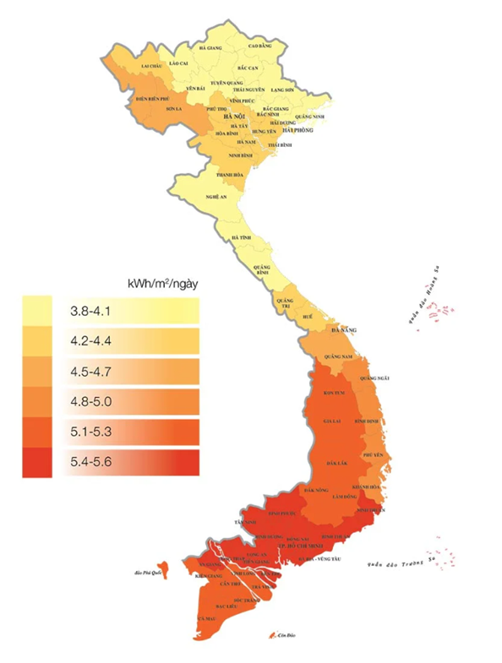

Figure 2‑4: Vietnam's map of solar radiation

In general, Vietnam has made great steps toward utilizing solar energy as a clean and sustainable energy source, and as the technology advances and costs continue to drop, further growth is anticipated in the years to come.

## Solar panel

A solar panel is an electrical device used to convert sunlight energy into electrical energy. It is sometimes referred to as a solar cell or a photovoltaic cell. For a variety of purposes, it is a commonly utilized sustainable and renewable energy source.

Light energy is absorbed by the photovoltaic cells within the battery when sunshine strikes the solar panel. Photovoltaic cells are semiconductor elements containing on the surface many light sensors called photodiodes that are used to convert light energy into electrical energy. The intensity of the panels' current, voltage, and resistance depends on the amount of light shining on them. Photovoltaic cells are created by assembling photovoltaic cells into blocks (a panel typically has 60 or 72 of these cells). Photovoltaic cells can operate under sunlight or artificial light.

These days, crystalline silicon is the primary component used in solar panels. There are three varieties of solar panels composed of crystalline silicon: monocrystalline, polycrystalline, and thin-film. Pure silicon crystals are poor electrical semiconductors, so silicon molecules have better electrical conductivity than when mixed with other impurities. When silicon combines with group III atoms (such as aluminum or gallium), it forms p-type semiconductors (positive, carrying positive charge carriers). When silicon combines with group V atoms (such as phosphorus or arsenic), it creates n-type semiconductors (negative, carrying negative charge carriers).

### Structure

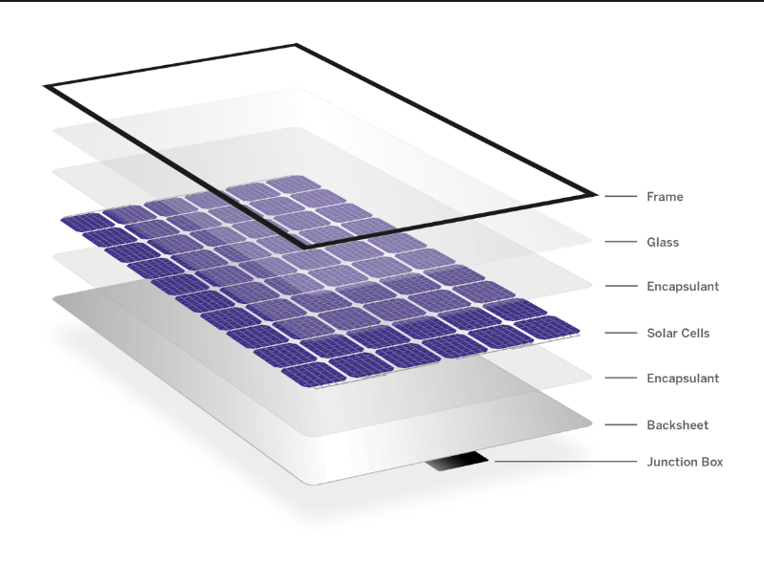

Figure 2‑5: Solar panel structure

A solar panel is composed of multiple parts that combine to produce electricity using solar radiation. A solar panel's primary parts are:

Frame: The frame is an integral part of a solar panel. Frames, which are usually composed of stainless steel or aluminum, aid in shielding solar cells and other components from environmental elements and physical strain.

Glass: Placed on top of the solar panel is a clear layer called glass. In addition to offering mechanical robustness, it protects the solar cells and aids in the transmission of sunlight.

Encapsulant: The encapsulant is usually made of a transparent and durable material called ethylene-vinyl acetate (EVA). It serves as a barrier to keep off moisture, dust, and other potential harm from getting to the solar cell. Guarantees the durability and dependability of solar panels. Additionally, EVA encapsulation also helps to secure the solar panels in place and enhance their durability.

Solar cells: Solar cells, also known as photovoltaic cells, are the heart of a solar panel, as they are responsible for converting sunlight into electricity. The two primary forms of silicon used in solar panels are monocrystalline and polycrystalline, and the performance of a solar panel is dependent on both the type of cell and the silicon's characteristics. It can be divided into P (positive) layers to create a voltage difference and generate a continuous current.

Back sheet: The back sheet is a protective layer located on the backside of the solar panel. Polymer, PVF, PP, and PET are a few materials that are frequently utilized to create battery panels. Depending on the manufacturer and module, they can be clear or black in addition to their typical white color.

Junction box: The junction box is a crucial part, situated on the rear of the solar panel. The junction box is a container that houses electrical connections and protection devices, which is attached to the solar panel. It provides a location for connecting the wires from the photovoltaic cells and generating the electrical output of the solar panel. The junction box protects the connections and may include control devices such as voltage regulators and overcurrent protection.

### Working principle

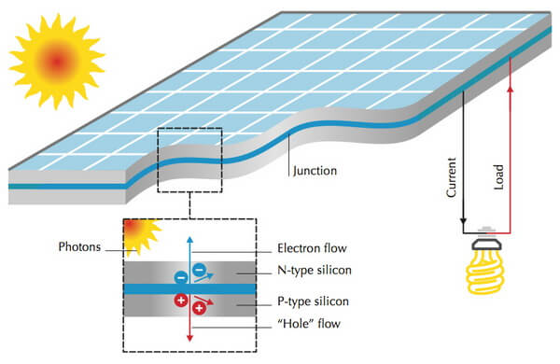

Figure 2‑6: The working principle of solar cell

The operating principle of solar cells is based on the photovoltaic effect, sometimes referred to as the solar effect. The photovoltaic cells inside the solar cell produce free electrons and an electric current when sunlight strikes them.

When sunlight strikes the battery, light energy is absorbed by the semiconductor material. The interaction of the positive and negative charges leads to their separation from one another when an electron-hole pair is formed. Holes travel into the P area, and electrons enter the N region. The process of separating the electron-hole pairs creates a phenomenon called voltage, or electric potential. This voltage produces a potential difference between the P and N regions, and an electrical circuit is created. A continuous current is produced by the free electrons moving from the N area to the P region due to the voltage produced in the solar panel. It is possible to gather this current and use it to power systems and gadgets with electricity.

### Application

Solar batteries have been and are being applied in many different areas of our lives.

Transportable power supply

This power source will provide electricity for electrical equipment anywhere. Particularly in isolated locations, on islands, and in the ocean—areas devoid of grid electricity. Applications for portable power sources such as solar pairs, solar umbrellas, and solar clothing.

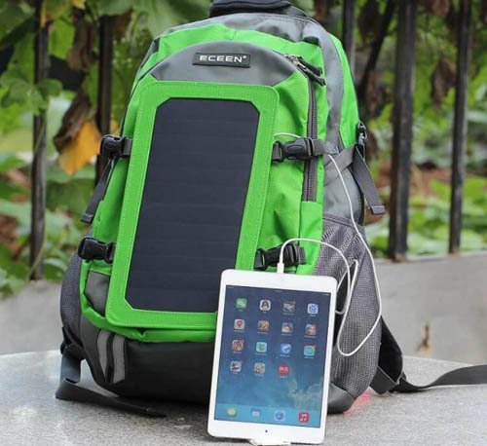

Figure 2‑7: Solar-powered backpack

Built-in to the apparatus

The integration of solar panels brings a difference to the devices. It not only brings aesthetics but also ensures convenience and is environmentally friendly. Solar batteries are often integrated into devices such as traffic signals, streetlights, vehicles, and artificial satellites.

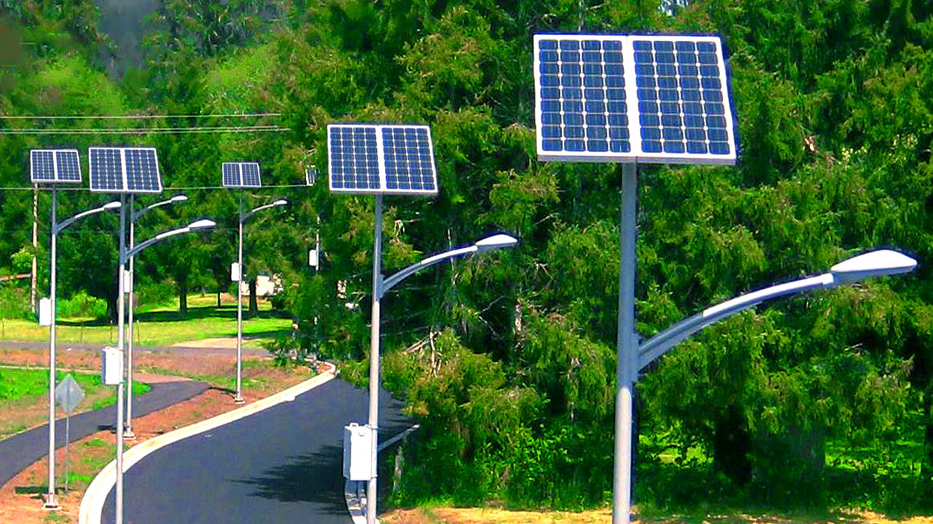

Figure ‑: Street lights powered by solar

Solar power plant

A solar power plant is a place that produces electricity based on the conversion of sunlight energy. The number of photovoltaic panels (also known as solar cells) in a solar power plant can reach hundreds or thousands.

How a solar power plant operates: Solar panels use the photovoltaic effect to directly turn the sunlight they receive into power. The current generated from the battery will be transferred to the transformer and other regulating devices to adjust and convert into usable electricity. Electricity is adapted and then fed into the national grid or used for designated uses.

Solar energy is now categorized as a clean renewable energy source that requires development encouragement. This energy source helps combat the continuing global climate change phenomenon in addition to supplying electricity for production and people's daily needs.

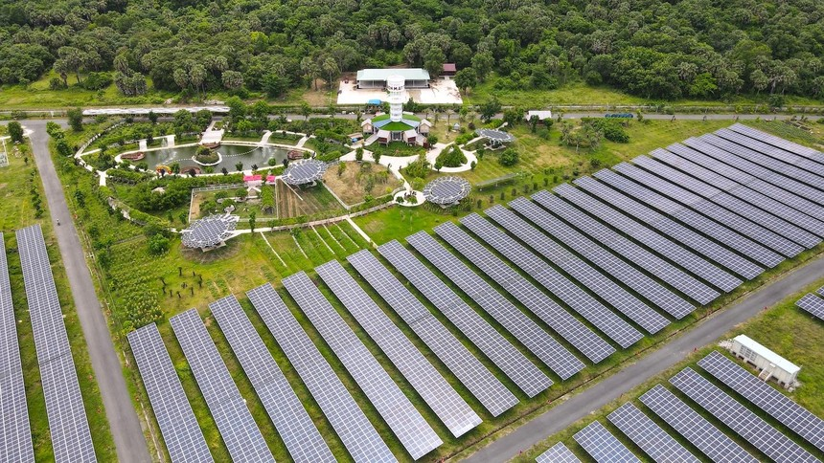

Figure 2‑9: An Hao solar power plant

Power source for building

The building's power supply is one of the practical fixes that can result in significant cost savings. Moreover, the roof-mounted solar panels contribute to the house's decreased heat.

In addition to contributing to environmental protection, using solar electricity at home shows off a contemporary way of living.

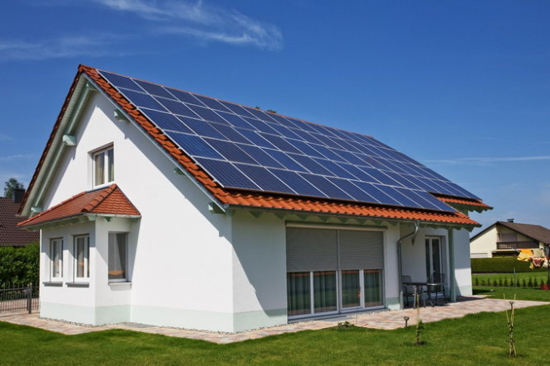

Figure 2‑10: The house is equipped with solar batteries

## Overview of the Internet of Things

What is the Internet of Things?

These days, creating applications for the Internet is becoming more and more necessary. IoT is also a significant technology since it allows us to develop a wide range of applications that touch nearly every aspect of life.

The Internet of Things, or IoT for short, refers to a system where physical objects, devices, and machines are interconnected through the Internet and can exchange data and interact without human intervention. These systems are made to gather and share data, automate procedures, and boost productivity across a range of sectors, including manufacturing, transportation, healthcare, and more. IoT systems typically include sensors, actuators, microcontrollers, and cloud-based software platforms that enable real-time monitoring, analysis, and control of connected devices. IoT systems' goal is to build a smarter, more connected world that will improve our everyday lives and the wider community.

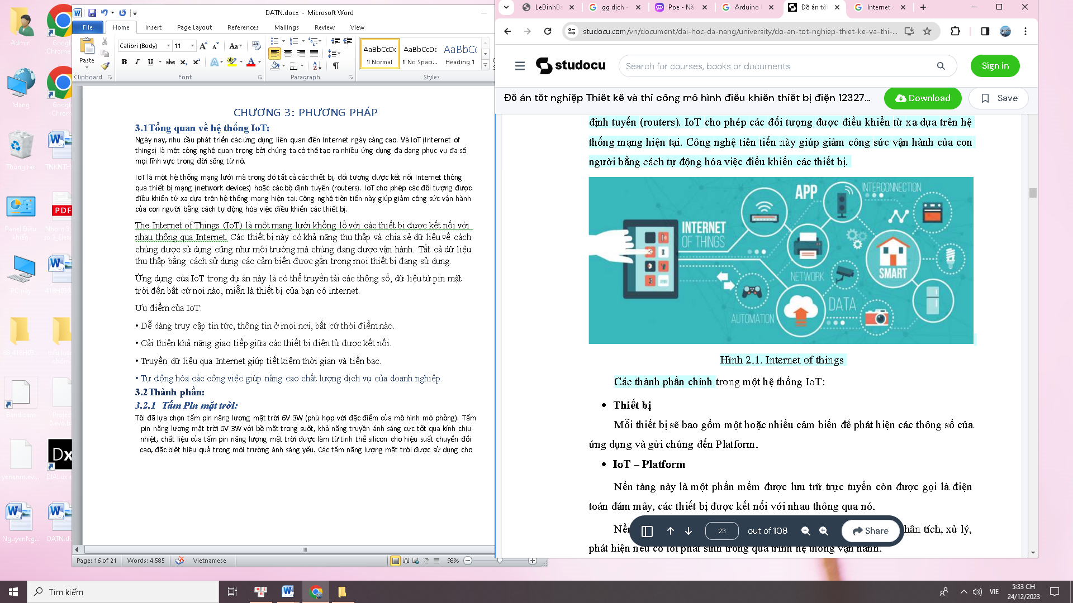

Figure 2‑11: Internet of Things

The Internet of Things (IoT) offers numerous benefits across various sectors and aspects of our lives.

* News and information are always easily accessible and places.
* Time and money are saved when data is transmitted via the Internet.
* Improves communication between connected electronic devices.

Automating tasks helps improve the service quality of the business.

# METHODOLOGY

## System overview

With this system, the solar panel will collect energy from sunlight and use it to power the devices. The photodiode light sensors will measure the level of brightness and help determine the direction and intensity of sunlight. The Solar charge control will manage the charging and discharging process of the battery to ensure optimal energy usage.

The servo motor will adjust the tilt angle of the solar panel based on data from the light sensors. The Lora SX1278 and Wi-Fi ESP32 modules enable data transmission from the sensors and controller to a remote-control center. The Arduino Uno R3 will serve as the central controller and data processor, working with other components in the system.

Finally, the Blynk app will provide a user interface on a mobile phone, allowing users to remotely monitor the system's status and performance.

## Components

### Solar panel

The solar panel is in charge of gathering solar radiation, turning it into electrical energy, storing it, and powering systems and equipment.

I chose a 6V 3Wsolar panel (which matches the characteristics of the simulation). This 6V 3W solar panel features a transparent surface, great light transmission through heat-resistant glass, and high conversion efficiency due to its silicon crystal construction. It performs particularly well in low-light conditions.

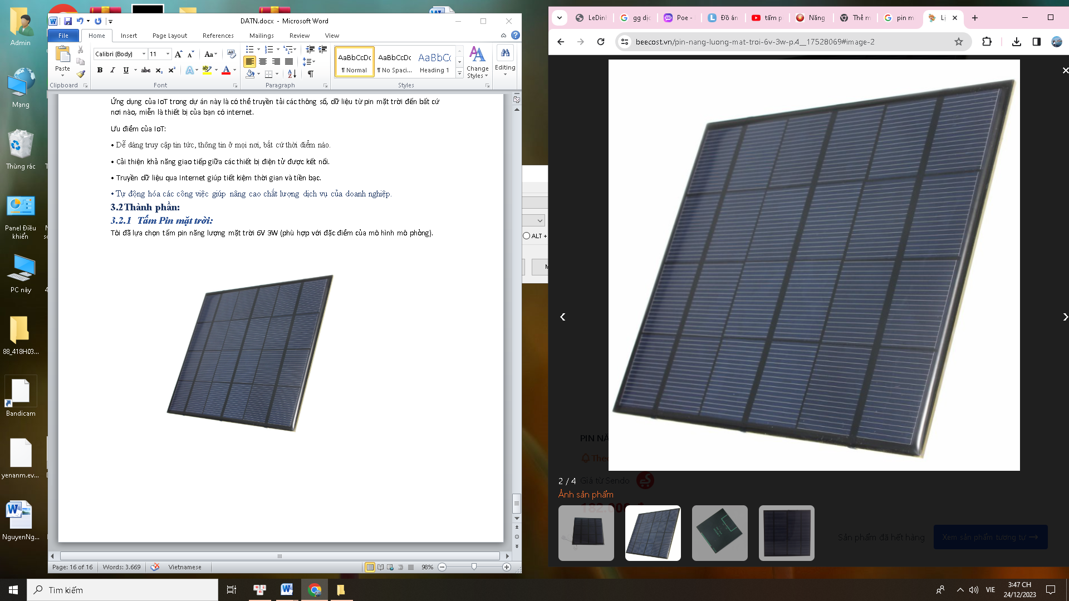

Figure 3‑1: Solar panel

Table ‑: Solar panel technical speFigure ‑cifications

|  |  |
| --- | --- |
|  | Parameter |
| Maximum Output Voltage | 7.2VDC |
| Average Voltage | 6VDC |
| Maximum Current | 0.52A |
| Maximum Power | 3W |
| Weight | 50g |
| Dimensions | 145 x 145 x 3 mm |

### Solar charge control

An essential part of a solar power system that helps control the amount of electrical charge entering and leaving batteries are solar charge controllers. A solar charge controller's primary job is to stop overcharging, over-discharging, and reverse charging, which can shorten battery life and even cause damage to the battery. To guarantee that solar panels run as efficiently as possible, solar charge controllers also assist in controlling the voltage and current output of the panels.

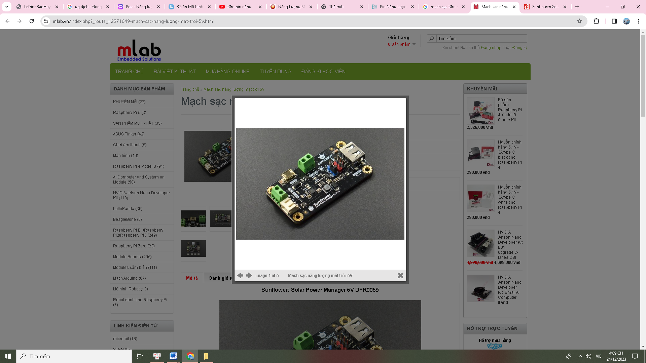

Figure ‑: Solar power manager 5V

Solar power manager 5V is a solar charge controller specifically designed to manage the charging and discharging of lithium batteries using 5V solar panels as input power. It ensures efficient energy use, extends battery life, and protects connected components in solar applications.

The controller also incorporates the MPPT (Maximum Power Point Tracking) charging feature for the purpose of optimizing the battery charging process.

MPPT (Maximum Power Point Tracking) là một thuật toán mà bộ điều khiển sạc sử dụng giúp cho các tấm pin mặt trời kết nối vào nó nhằm hấp thụ tối đa năng lượng mặt trời. Khi tia nắng mặt trời thay đổi thì điểm công suất cực đại của tấm pin sẽ thay đổi theo. Lúc này thì bộ điều khiển sạc phát huy tác dụng. Bộ điều khiển sạc sẽ điều chỉnh sao cho mối quan hệ V-I luôn ở mức cực đại.

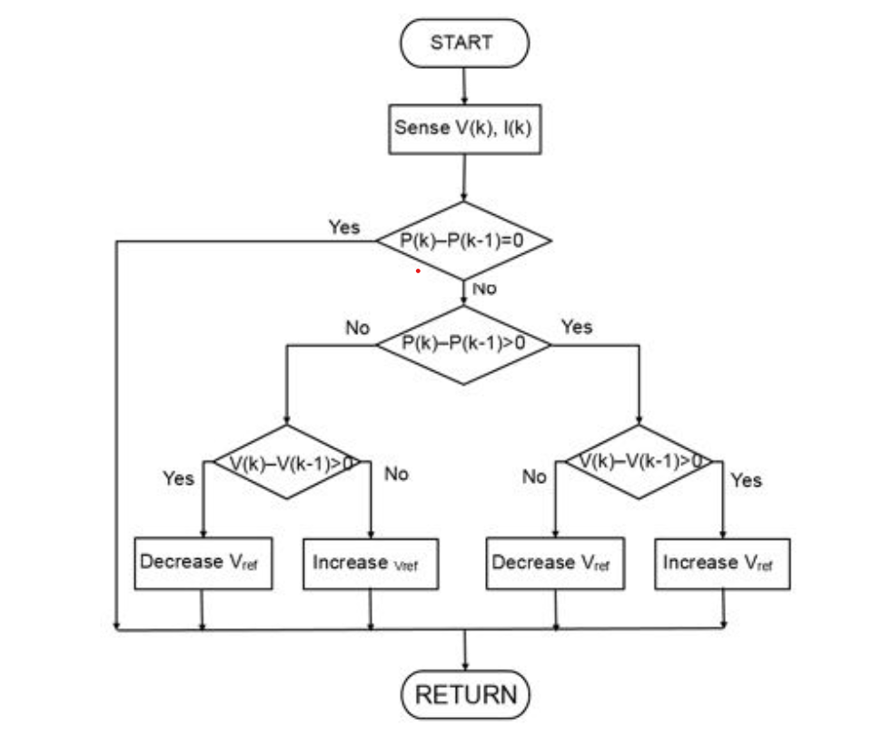

Figure ‑: flow chart

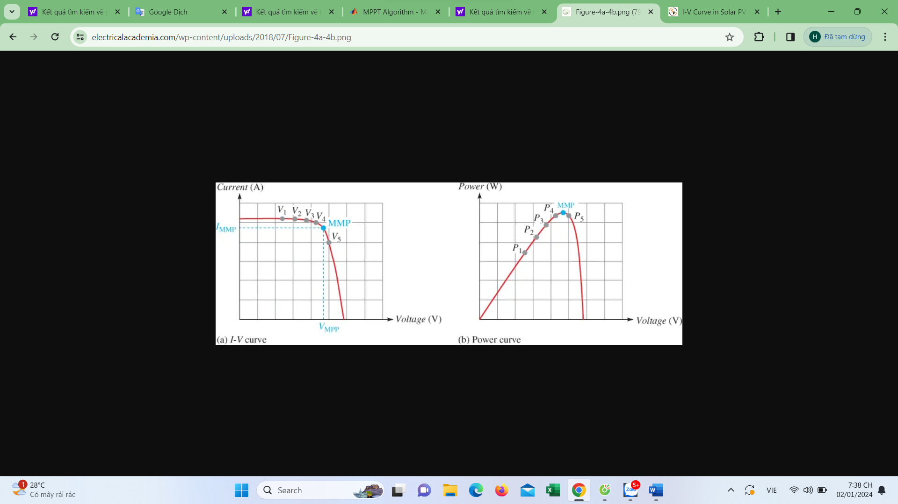

Figure ‑:

Ban đầu đo điện áp V(k) vsf dòng điện I(k) tại thời điểm k sau đó tính công suất tại thời điểm P(k) và lưu lại giá trị. Ta tiếp tục đo để lấy giá trị tại thời điểm k, khi đó giá trị trước trở thành P(k-1). Lấy p(k)- p(k-1) và theo dõi xem có bằng nhau hay không. Nếu bằng nhau thì điểm đang xét là điểm công suất cực đại. Nếu không bằng nhau thì so sánh lớn hơ hoặc nhỏ hơn không. Nếu lớn hơn 0 ta xét tiếp đến điện áp V(k) – V(k-1). Nếu như >0 thì tăng điện áp tham chiếu, ngược lại.

Table ‑: The solar power manager 5V technical specifications

|  |  |
| --- | --- |
|  | Parameter |
| Solar input voltage | 4.5V ~ 6V |
| Maximum charging current (USB IN/SOLAR IN) | 900mA. |
| Voltage cutoff (USB IN/SOLAR IN) | 4.2V (1%) |
| Input voltage (USB IN) | 5V |
| Output voltage (USB OUT) | 5V/1A |
| Battery input | Reverse polarity protection |
| Usb out | Short circuit, overcurrent, and overheat protection. |
| Solar in | Reverse polarity protection |
| Operating temperature | -40°C ~ 85°C |
| Dimensions | 33mm x 63mm |

### Battery

. The battery's primary function is to store electrical energy produced by sunlight. This is an essential component of a solar power system since it lets you store electricity for usage at night and ensures that demand for electricity is unaffected even in the event of a grid outage.

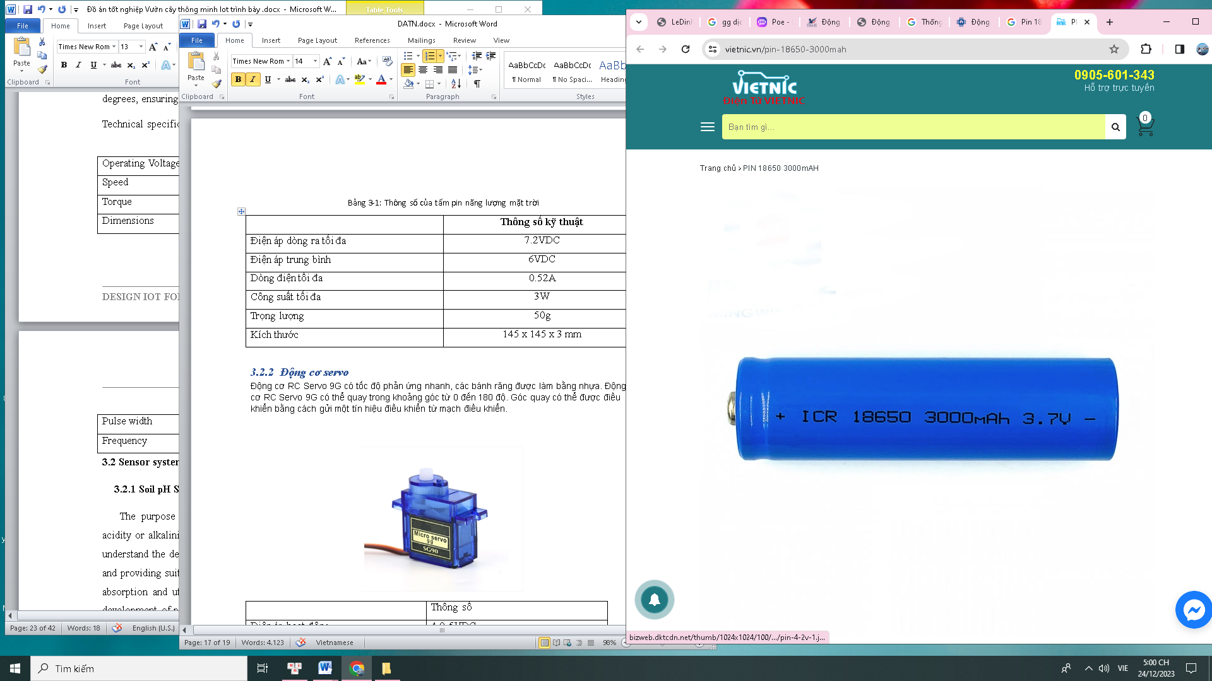

Figure ‑: Battery 18650

Table ‑: Technical specifications of the 18650 batteries

|  |  |
| --- | --- |
|  | Parameter |
| Battery type | 18650 Li-ion rechargeable battery |
| Average voltage | 3.7VDC |
| Capacity | 1200mAh |
| Average internal resistance | 40mΩ |
| Dimensions | 18x65mm. |

### Photodiode sensor

Photodiode sensors can be used to measure sunlight intensity. Through this measurement, the sensors is used to determine if light is present or absent so that battery charging and discharging can be adjusted accordingly. To prevent battery overload, the sensor sends a signal to lower the charging current when light intensity is high. On the other hand, to optimize battery charging efficiency in low-light conditions, the sensor may raise the charging current.

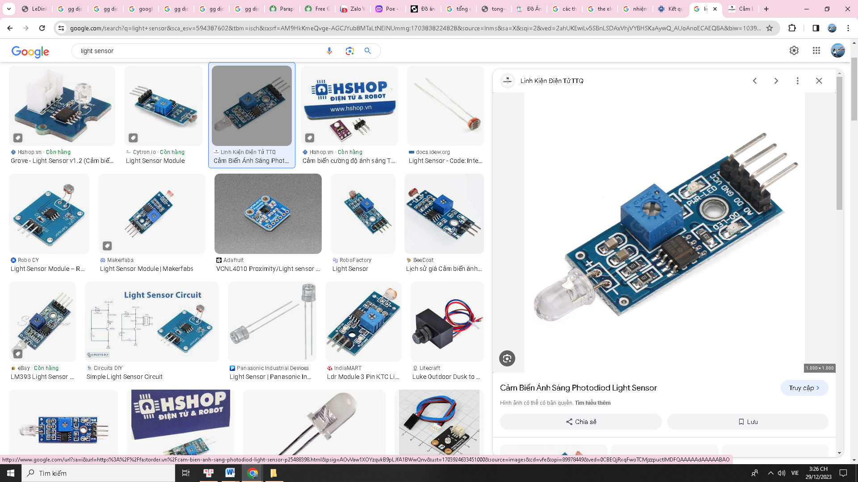

Figure ‑: Photodiode light sensor

Photodiode light sensors in solar battery systems can facilitate better battery performance and longevity in addition to controlling battery charging and discharging.

Table ‑: Technical specifications of photodiode light sensors

|  |  |
| --- | --- |
|  | Parameter |
| Power supply | 3.3-5VDC |
| Analog output | A0 |
| Digital output | D0 |
| Ground | GND |
| Dimensions | 30x16mm |

### Servo motor

The servo motor is utilized to change the solar panel's position depending on where the sun is in the sky. The motor is connected to a monitoring device using sensors. To modify the position of the solar panel, the tracking device uses this data to send a signal to the servo motor.

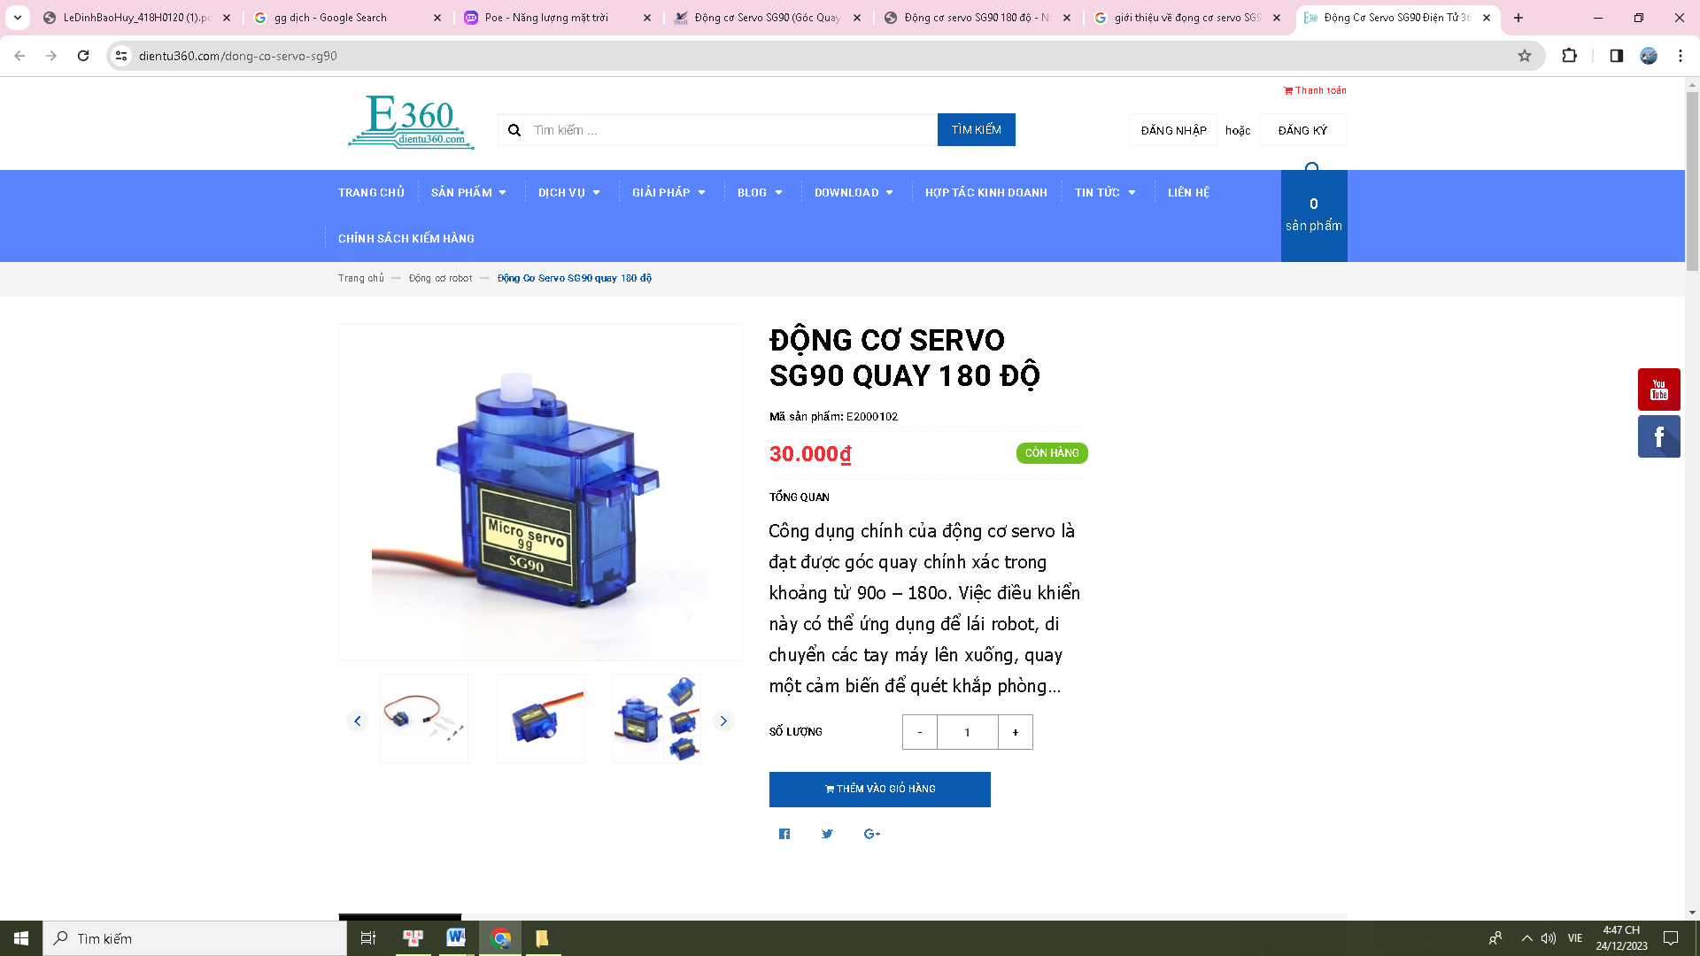

Figure ‑: RC Servo 9G motor

The RC servo 9G motor is capable of rotating within a limited range of angles, usually from 0 to 180 degrees. As the sun moves across the sky, a servo motor can be activated to rotate the solar battery in the direction of the sun, helping to ensure that the battery always faces the source of sunlight. This helps increase energy collection efficiency and optimize solar cell efficiency.

Table ‑: Technical specifications of the RC servo 9G motor

|  |  |
| --- | --- |
|  | Parameter |
| Operating Voltage | 4.8-5VDC |
| Speed | 0.12 sec/60 degrees (4.8VDC) |
| Torque | 1.6KG |
| Pulse width | 0-180 degrees |
| Frequency | 50Hz |
| Dimensions | 21x12x22mm |

### Lora

LoRa (Long Range) is a wireless communications technology developed to provide wide network connectivity and low power consumption for Internet of Things applications. LoRa technology's primary benefit is its long-range capability. It uses extremely little electricity and can transfer data across several kilometers.

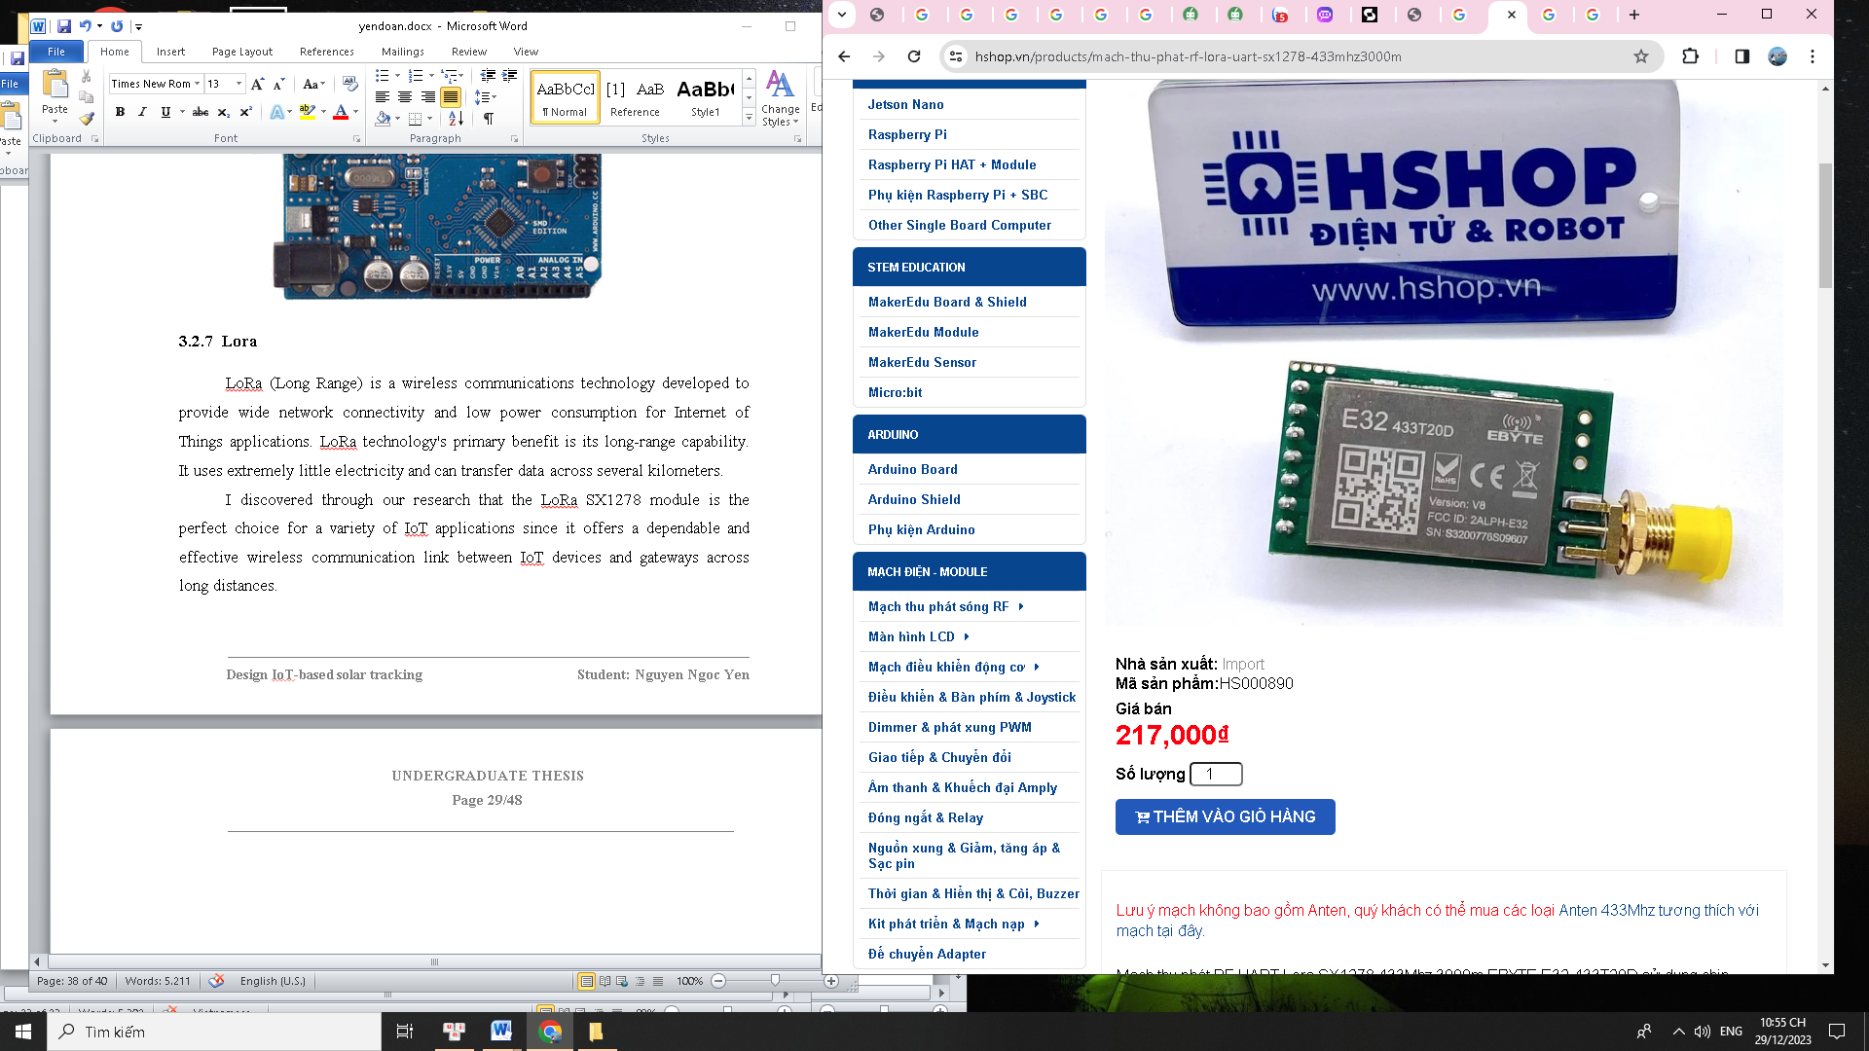

Figure ‑: Lora SX1278 433Mhz 3000m

LoRa SX1278 is designed to provide long-distance data transmission capabilities. In the absence of obstructions and shielding, it can transmit signals up to 3000 meters at an operational frequency of 433 MHz. LoRa technology can pass through many obstructions, including walls and buildings. This aids in the stable connection maintenance and data transmission of the SX1278 LoRa module in highly barrier-filled situations. It also allows multiple devices to send and receive data at the same time in a single transmission channel.

Table ‑: Technical specifications of the Lora SX1278 433Mhz 3000m

|  |  |
| --- | --- |
|  | Parameter |
| Operating voltage | 2.3 - 5.5 VDC |
| Communication voltage | 3.3V |
| Frequency | 410 - 441Mhz |
| Maximum transmission distance under ideal conditions | 3000m |
| data transmission rate | 0.3 - 19.2 Kbps |
| Dimensions | 21x36mm |

### Arduino

Arduino is essentially a microcontroller board designed to build and develop applications that interact with each other or with the environment conveniently and easily. In a solar battery system, Arduino performs the tasks of controlling and managing the battery system, collecting and processing data, and communicating with devices and users.

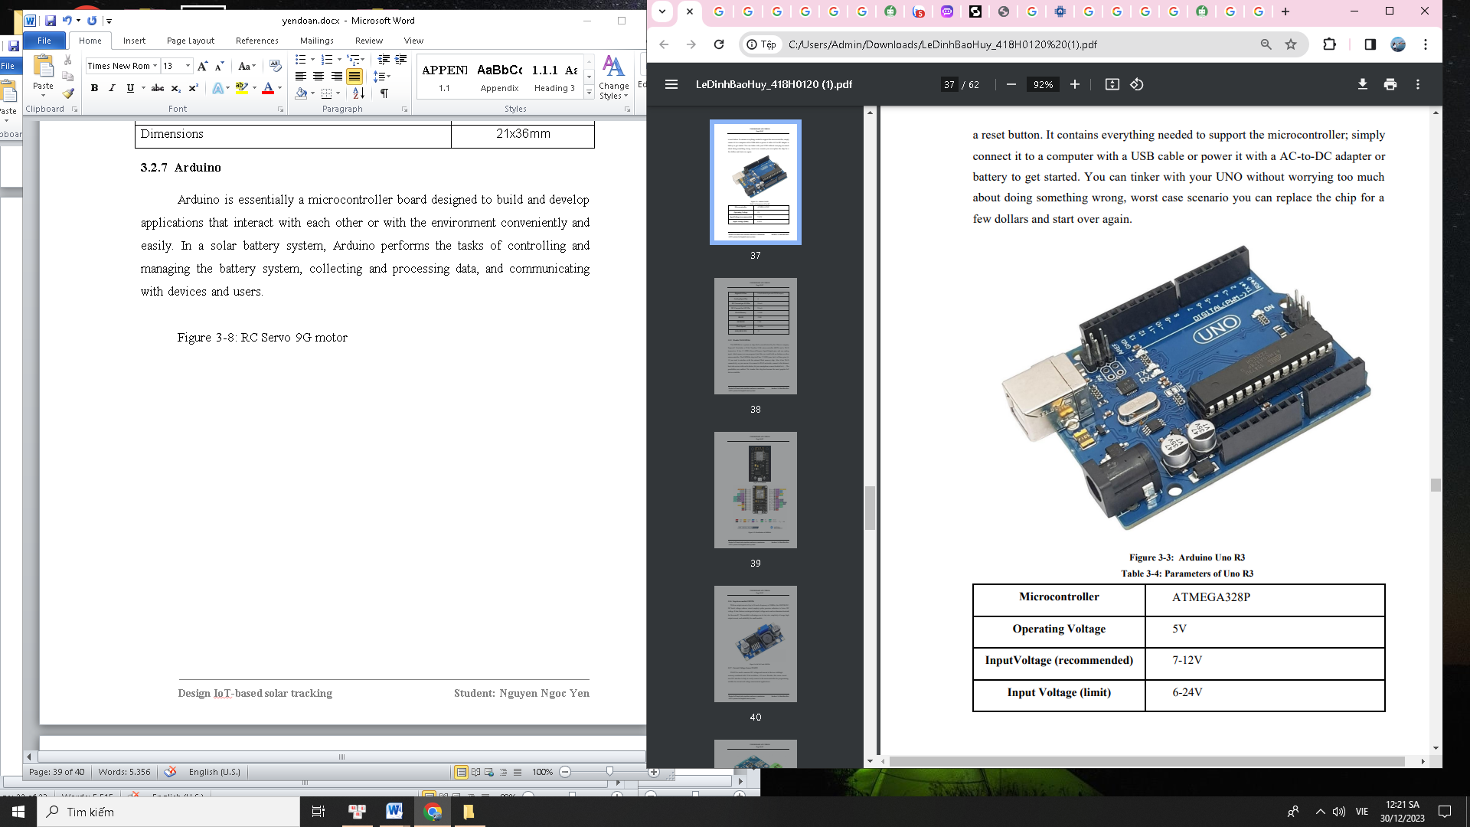

Figure ‑: Arduino Uno R3

Arduino Uno R3 is a microcontroller board based on the ATmega328P microcontroller. The Arduino family's most popular board is made to be flexible and simple to use. The board includes a 16 MHz quartz crystal, 6 analog inputs, and 14 digital input/output pins. Arduino Uno R3 can perform many tasks in a solar battery system, from controlling and monitoring the battery charging process to energy management. The flexibility and compatibility of the Arduino Uno R3 make it a useful tool in solar panel projects.

Table ‑: Technical specifications of the Arduino Uno R3

|  |  |
| --- | --- |
|  | Parameter |
| Microcontroller | ATMEGA328P |
| Operating voltage | 5V DC |
| Operating Frequency | 16 MHz |
| Current Consumption | 30mA |
| Input Voltage | 5-12V DC |
| Digital I/O pins | 14 (6 pins with hardware PWM) |
| Analog input pins | 6 (10-bit resolution) |
| DC current per I/O pin | 20 mA |
| DC current for 3.3V pin | 50 mA |
| Flash memory | 32 KB |
| SRAM | 2 KB |

### Module Wi-Fi ESP32

The ESP32 is a potent microcontroller built by Espressif Systems. With Wi-Fi and Bluetooth connectivity, powerful performance, and flexibility, the ESP32 is widely used in developing IoT applications.

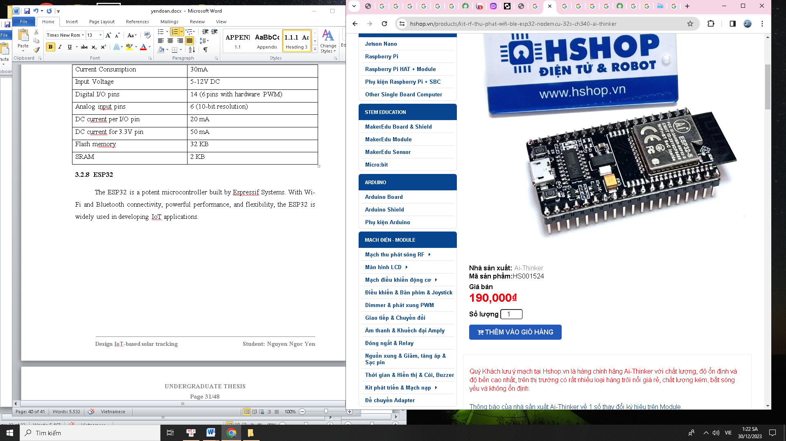

Figure ‑: ESP32

The ESP32 can be used to gather data from sensors and measuring devices such as light, voltage, and current sensors. By connecting these sensors to the ESP32, it is possible to collect data on battery performance, energy production level, ambient temperature, and other parameters related to the solar PV system. After collecting data, the ESP32 can process this data according to the needs of the application.

Furthermore, by programming the ESP32 and connecting it to the controller, one may utilize it to operate peripheral devices. This allows for the automation of tasks like adjusting lights or other devices based on ambient conditions and measurement data.

Table ‑: Technical specifications of the ESP32

|  |  |
| --- | --- |
|  | Parameter |
| Operating voltage | 2.2-3.6V |
| ROM | 448KBytes |
| SPRAM | 520 KBytes |
| Rated current | Minimum 500mA |
| Processing speed | 80Mhz – 240Mhz |

## Design of an electronic circuit.

Electronic circuit design is the job of arranging and connecting discrete electronic components on a circuit board to become a complete circuit, performing certain functions.

In this topic, you want the solar panel navigation system to operate effectively. We need to design an electronic circuit to process signals from the light sensor and control the servo motor  whilemotororing and collecting data through the ESP32 and sending it to the Blynk application for remote display and management.

### Control circuit